SUG Observation Report — 26 Sep 2013, AJ4CO Observatory

Observer |  | Storm Activity |  | CML-III | Io φ
On Duty: | unattended | Begin: | 1125 | 262° | 201°
Off Duty: | unattended | End: | 1150 | 283° | 206°

Location: | High Springs, Florida
Observer: | Dave Typinski
Instrumentation: | DPS  FS-200  RJ Receivers
Body: | Jupiter
Storm Type: | non-Io-A
Data File(s): | AJ4CO-DPS-130926111500.sps  AJ4CO-FS-200-130926111500.sps  AJ4CO-RSP-130926111500.spd

Observer Log
Observable emission ended just after onset of morning increase in HF terrestrial propagation at 20 MHz.

Dominant polarization: RCP.

Io-CML Phase Plane

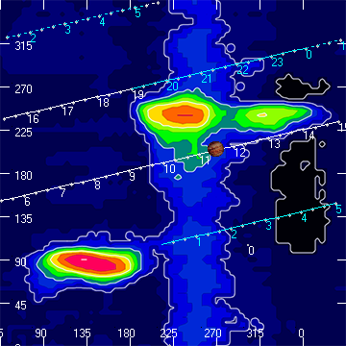

RJP Sky View

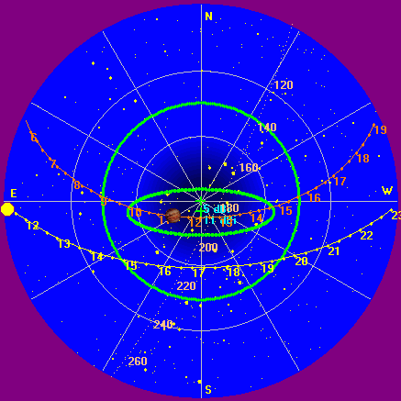

US-TEC Map

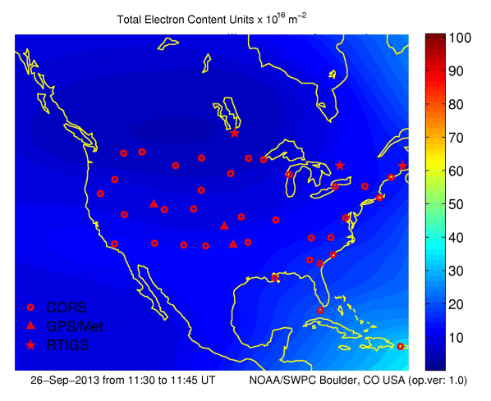

Kp index, 3-hour average: | 0

CONUS Lightning Activity

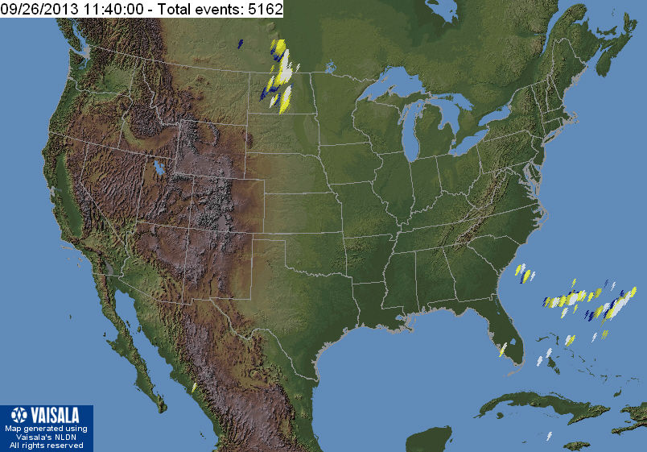

Instrumentation: | DPS on XTFD  30 kHz IF  300 channels  17–33 MHz

Calibration Scale

None available; using RSS 2.2.16.

Overview Spectrogram

RCP Top, LCP Bottom

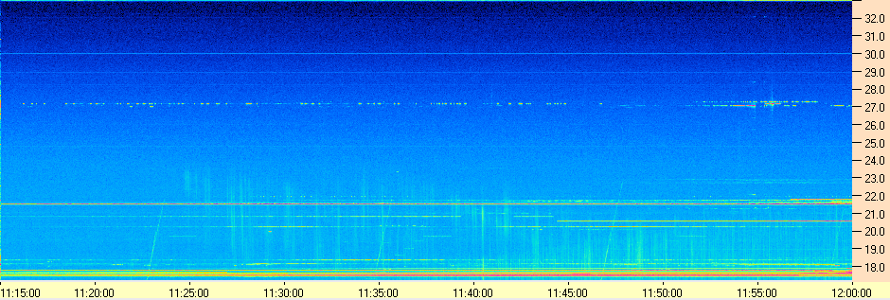
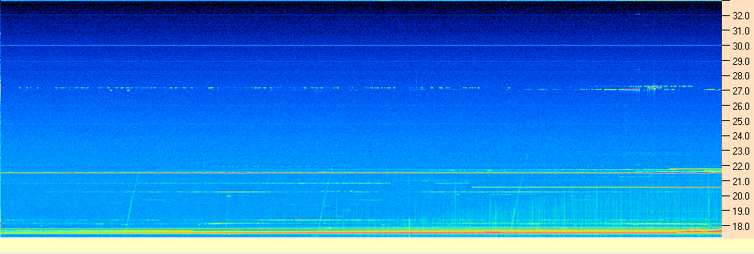

Instrumentation: | FS-200 on SJ Array  30 kHz IF  200 Channels  18–26 MHz

Calibration Scale

None available; using RSS 2.2.16.

Overview Spectrogram

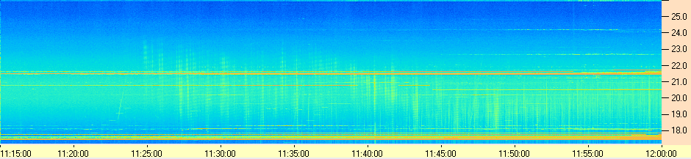

Instrumentation: | Jove Receivers on SJ Array  19.95 and 20.25 MHz

Overview Strip Chart

