SUG Observation Report — 27 Sep 2013, AJ4CO Observatory

Observer On Duty (UTC): | unattended
Observer Off Duty (UTC): | unattended

Storm Activity (UTC) |  | CML-III | Io φ | Off Axis | D_{E} | JS ∠ | Δ JE
Begin: | 1355 | 149° | 66° | 22° | +1.8° | –77° | 5.3 AU
End: | 1425 | 167° | 70° | 29° | +1.8° | –77° | 5.3 AU

Location: | High Springs, Florida
Observer: | Dave Typinski
Instrumentation: | DPS  FS-200  RJ Receivers
Body: | Jupiter
Storm Type: | Io-B
Data File(s): | AJ4CO-DPS-130927134500.sps  AJ4CO-FS-200-130927134500.sps

Observer Log
N event only.

Dominant polarization: RCP.

Io-CML Phase Plane

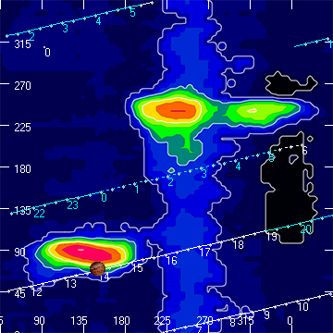

RJP Sky View

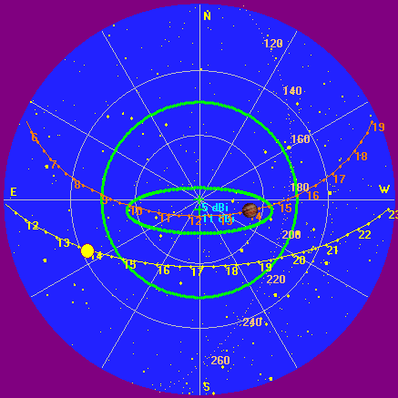

US-TEC Map

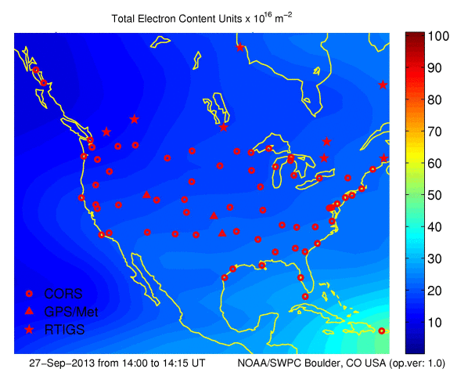

Kp index, 3-hour average: | 1

CONUS Lightning Activity

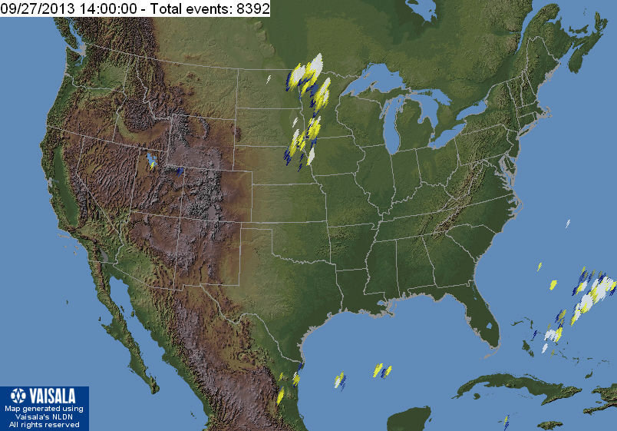

Instrumentation: | DPS on XTFD  30 kHz IF  300 channels  17–33 MHz

Calibration Scale None available; using RSS 2.2.16.

Overview Spectrogram — RCP Top, LCP Bottom

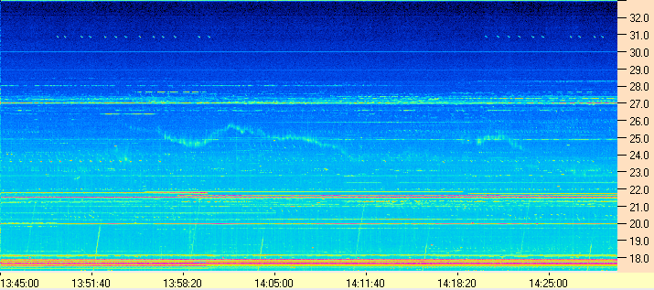
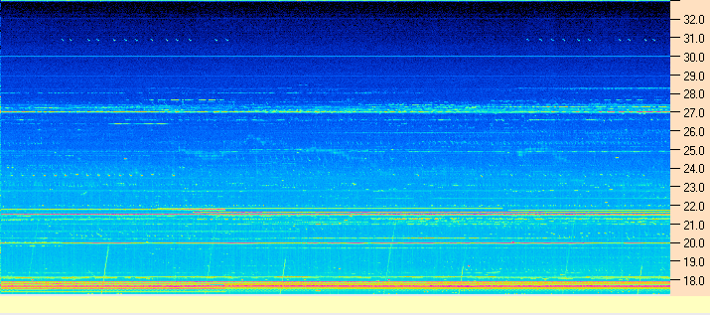

Instrumentation: | FS-200 on SJ Array  30 kHz IF  200 Channels  18–26 MHz

Calibration Scale

None available; using RSS 2.2.16.

Overview Spectrogram

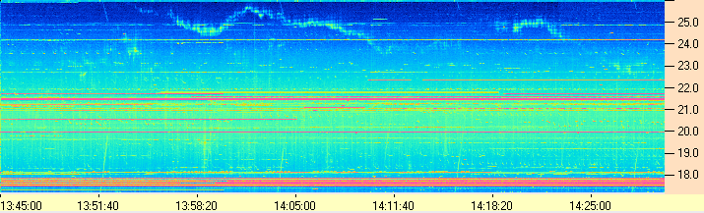

Instrumentation: | Jove Receivers on SJ Array  19.95 and 20.25 MHz

Overview Strip Chart

No emission at 20 MHz.

