SUG Observation Report — 03 Oct 2013

Observatory: | AJ4CO Observatory | Instrumentation: | FS-200 on SJ Array
Location: | High Springs, Florida
Observer: | Dave Typinski

Observer On Duty (UTC): | unattended | Body: | Jupiter
Observer Off Duty (UTC): | unattended | Storm Type: | non-Io-A

Storm Activity (UTC) |  | CML-III | Io φ | Off Axis | D_{E} | JS ∠ | Δ JE
Begin: | 1020 | 202° | 176° | 16° | +1.76° | –82° | 5.21 AU
End: | 1130 | 244° | 186° | 8° | +1.76° | –82° | 5.21 AU

Interval |  |  |  |  |  | F_{hi} | F_{lo} |  |  |  | Drift |  | Rot Rate | TEC
# | (UTC) | L | S | N | Pol | MHz | MHz | CML | Io | ML | MHz/m | FB | #/MHz @ F | 10¹⁶/m²
1 | 1020–1040 | X |  |  |  | 18 | 25 | 208 | 178 |  |  | X | 1.7 @ 20 | unavail
2 | 1110–1130 | X |  |  |  | 19 | 26 | 238 | 185 |  |  | X | 3.0 @ 20 | unavail
3
4
5
6

Interval – Time during which something interesting was observed  L, S, N – Indicates presence of L bursts, S bursts, and N events  Pol – Dominant circular polarization observed  Fhi, Flo – Frequency range of observed emission  CML, Io – System III CML and Io phase during noted interval | ML – indicates presence of modulation lanes  Drift – Observed modulation lane drift rate in MHz per minute  FB – indicates presence of Faraday bands  Rot Rate – Observed Faraday rotation rate in rotations per MHz at observing frequency F  TEC – Ionospheric vertical total electron count during noted interval as reported by NGDC

Observer Notes

Data File(s): | AJ4CO-FS-200-131003102000.sps

Io-CML Phase Plane

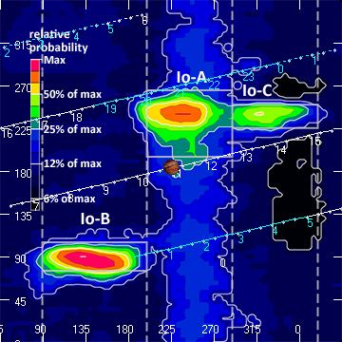

RJP Sky View

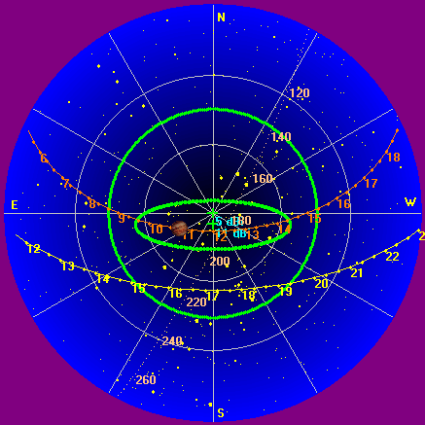

US-TEC Map

Not available do to FedCo shutown.

Kp index, 3-hour average: | 1

CONUS Lightning Activity

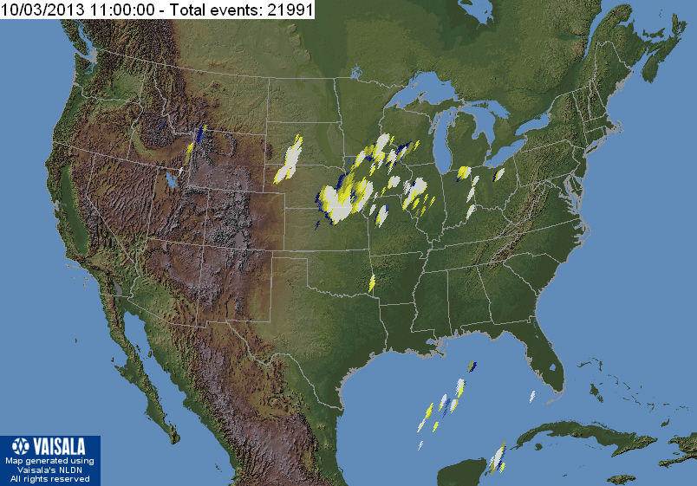

Instrumentation: | FS-200 on SJ Array  30 kHz IF  200 Channels  18–26 MHz

Calibration Scale

Overview Spectrogram

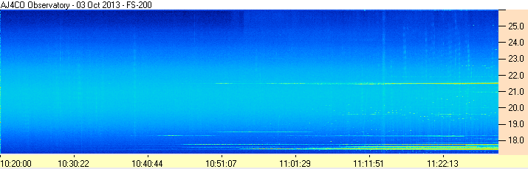

Interval #1

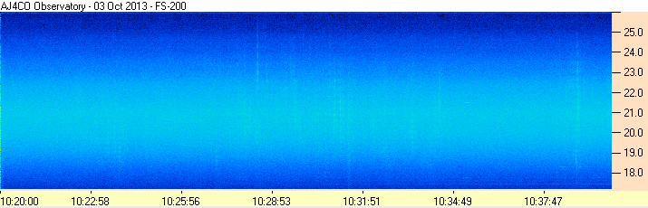

Interval #2

