SUG Observation Report — 05 Oct 2013

Observatory: | AJ4CO Observatory | Instrumentation: | DPS on XTFD
Location: | High Springs, Florida |  | FS-200 on SJ Array
Observer: | Dave Typinski |  | Jove Rx on SJ Array (OFFLINE)

Observer On Duty (UTC): | unattended | Body: | Jupiter
Observer Off Duty (UTC): | unattended | Storm Type: | Io-A

Storm Activity (UTC) |  | CML-III | Io φ | Off Axis | D_{E} | JS ∠ | Δ JE
Begin: | 1130 | 185° | 233° | 6° | +1.75° | –84° | 5.17 AU
End: | 1330 | 258° | 250° | 22° | +1.75° | –84° | 5.17 AU

Interval |  |  |  |  |  | F_{hi} | F_{lo} |  |  |  | Drift |  | Rot Rate | TEC
# | (UTC) | L | S | N | Pol | MHz | MHz | CML | Io | ML | MHz/m | FB | #/MHz @ F | 10¹⁶/m²
1 | 1135–1215 | X |  |  | RCP | 18 | 23 | 199 | 236 |  |  | X | 3.3 @ 20
2 | 1240–1330 | X |  |  |  | 17 | 26 | 243 | 246 |  |  | X | 5.5 @ 20
3
4
5
6

Interval – Time during which something interesting was observed  L, S, N – Indicates presence of L bursts, S bursts, and N events  Pol – Dominant circular polarization observed  Fhi, Flo – Frequency range of observed emission  CML, Io – System III CML and Io phase during noted interval | ML – indicates presence of modulation lanes  Drift – Observed modulation lane drift rate in MHz per minute  FB – indicates presence of Faraday bands  Rot Rate – Observed Faraday rotation rate in rotations per MHz at observing frequency F  TEC – Ionospheric vertical total electron count during noted interval as reported by NGDC

Observer Notes
Very weak storm, details visible only in (relatively) high gain SJ Array.

Data File(s): | AJ4CO-DPS-131005112000.sps  AJ4CO-FS-200-131005112000.sps

Io-CML Phase Plane

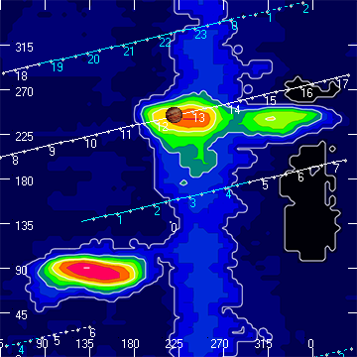

RJP Sky View

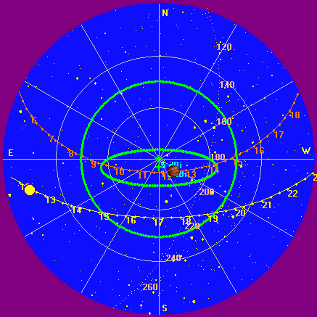

US-TEC Map

Unavailable due to FedCo shutdown.

Kp index, 3-hour average: | 1

CONUS Lightning Activity

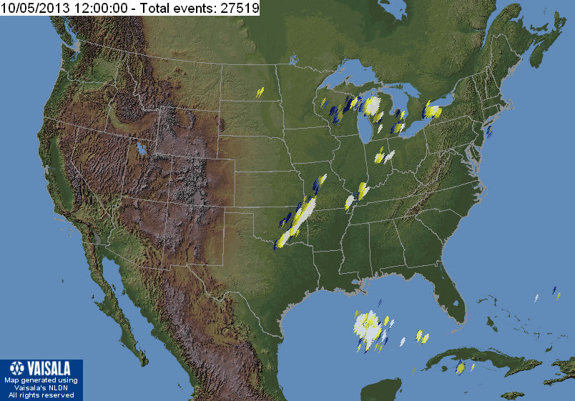

Instrumentation: | DPS on XTFD  30 kHz IF  300 channels, 53 kHz spacing  17–33 MHz

Calibration Scale

Overview Spectrogram (675 px)

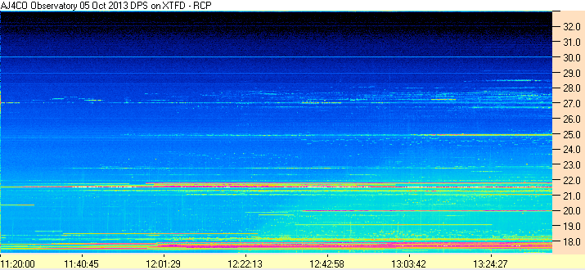
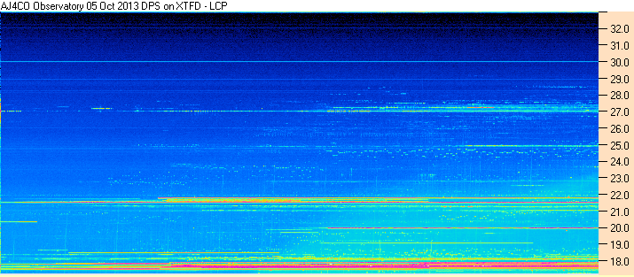

Instrumentation: | FS-200 on SJ Array  30 kHz IF  200 Channels  18–26 MHz

Calibration Scale

Overview Spectrogram (675 px)

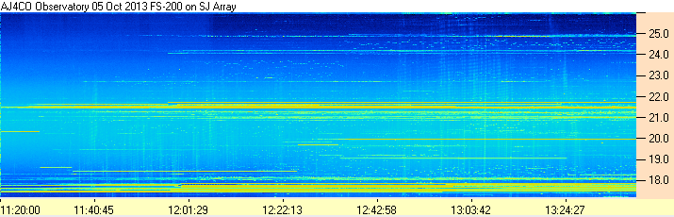

Interval 1

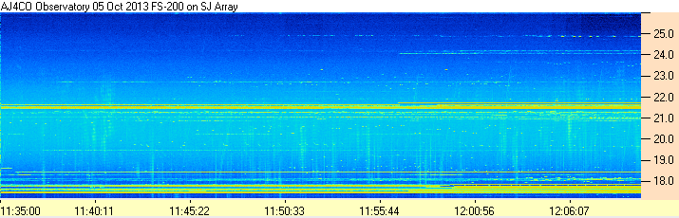

Interval 2

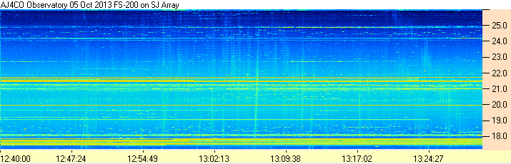
Detail 1

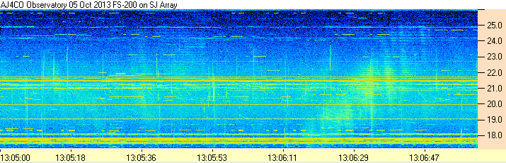

Detail 2

