SUG Observation Report — 15 Oct 2013

Observatory: | AJ4CO Observatory | Instrumentation: | DPS on XTFD
Location: | High Springs, Florida |  | FS-200 on SJ Array
Observer: | Dave Typinski |  | Jove Rx on SJ Array

Observer On Duty (UTC): | unattended | Body: | Jupiter
Observer Off Duty (UTC): | unattended | Storm Type: | Io-B

Storm Activity (UTC) |  | CML-III | Io φ | Off Axis | D_{E} | JS ∠ | Δ JE
Begin: | 0815 | 132° | 82° | 42° | +1.71° | –93° | 5.02 AU
End: | 0940 | 184° | 94° | 24° | +1.71° | –93° | 5.02 AU

Interval |  |  |  |  |  | F_{hi} | F_{lo} |  |  |  | Drift |  | Rot Rate | TEC
# | (UTC) | L | S | N | Pol | MHz | MHz | CML | Io | ML | MHz/m | FB | #/MHz @ F | 10¹⁶/m²
1 | 0815–0940 | X | X |  | RCP | 17 | 26 | 158 | 88 |  |  | X
2
3
4
5
6

Interval – Time during which something interesting was observed  L, S, N – Indicates presence of L bursts, S bursts, and N events  Pol – Dominant circular polarization observed  Fhi, Flo – Frequency range of observed emission  CML, Io – System III CML and Io phase during noted interval | ML – indicates presence of modulation lanes  Drift – Observed modulation lane drift rate in MHz per minute  FB – indicates presence of Faraday bands  Rot Rate – Observed Faraday rotation rate in rotations per MHz at observing frequency F  TEC – Ionospheric vertical total electron count during noted interval as reported by NGDC

Observer Notes

Data File(s): | AJ4CO-DPS-131015080000.sps  AJ4CO-FS-200-131015080000.sps  AJ4CO-RSP-UT131015080000.spd

Io-CML Phase Plane

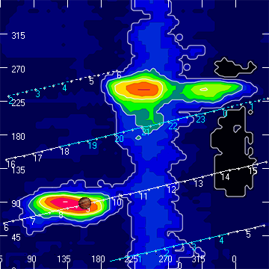

RJP Sky View

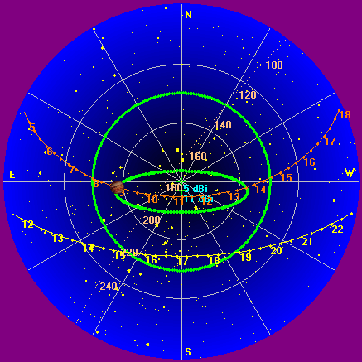

US-TEC Map

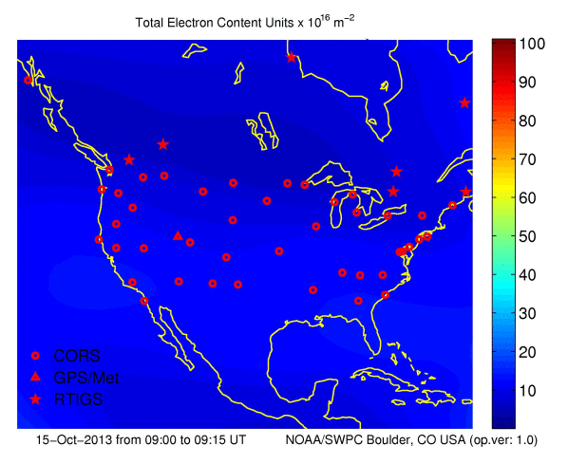

Kp index, 3-hour average: | 3

CONUS Lightning Activity

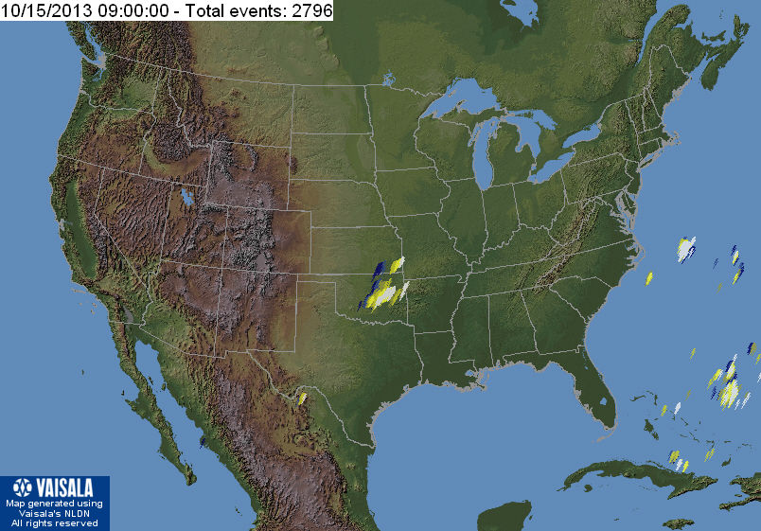

Instrumentation: | DPS on XTFD  30 kHz IF  300 channels, 53 kHz spacing  17–33 MHz

Calibration Scale

Overview Spectrogram (675 px)

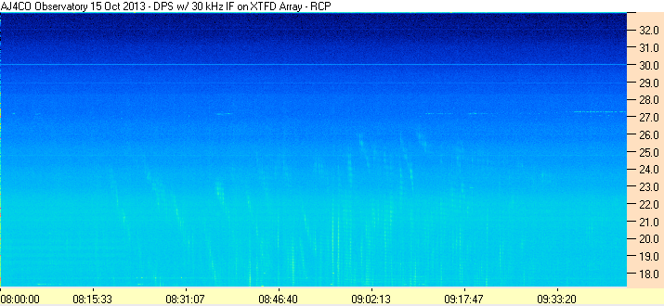
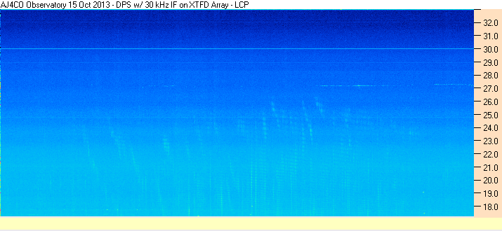

Interval #1

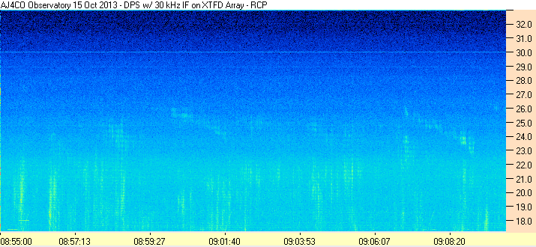
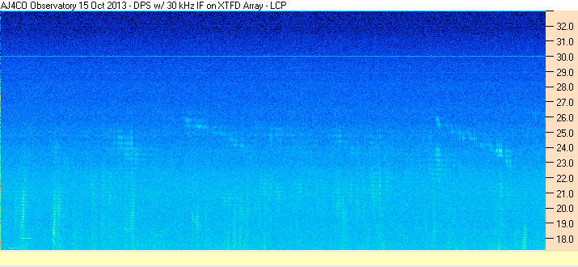

Instrumentation: | FS-200 on SJ Array  30 kHz IF  200 Channels  18–26 MHz

Calibration Scale

UNCALIBRATED

Overview Spectrogram (675 px)

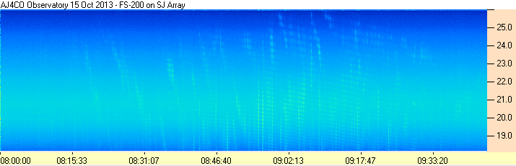

Interval 1

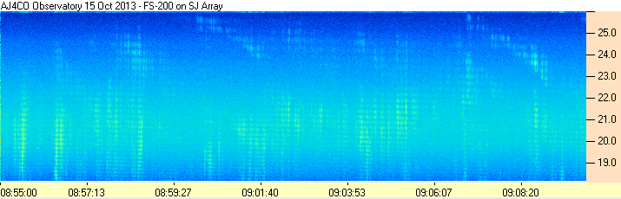

Instrumentation: | Jove Receivers on SJ Array  19.95 and 20.25 MHz

Overview Strip Chart
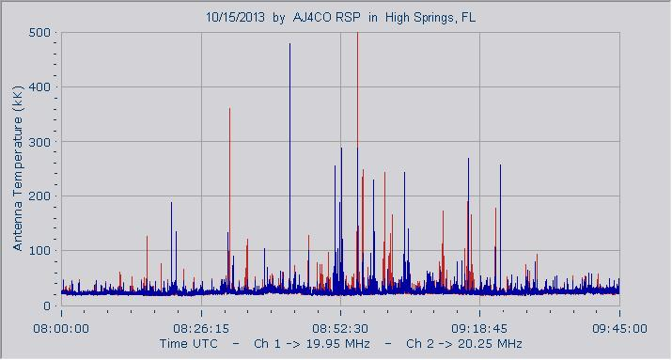

Interval #1
