SUG Coordinated Observation 28 Feb 2015, 0350-0400 RCP & Linear

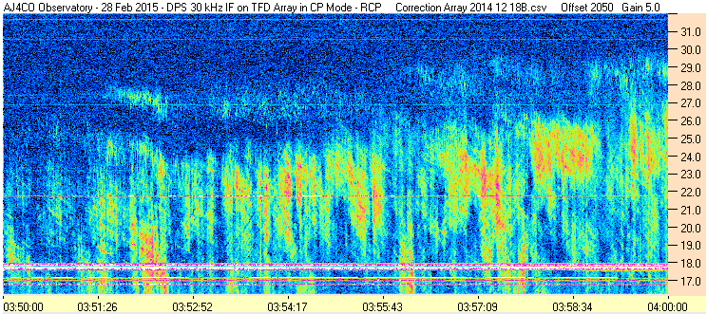

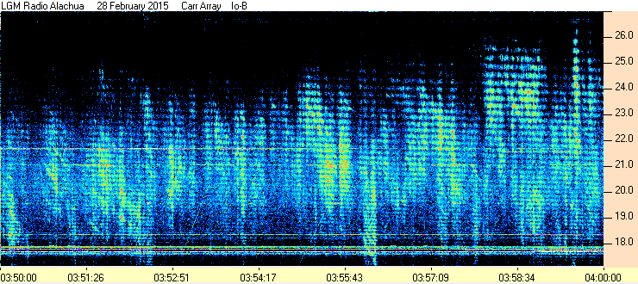

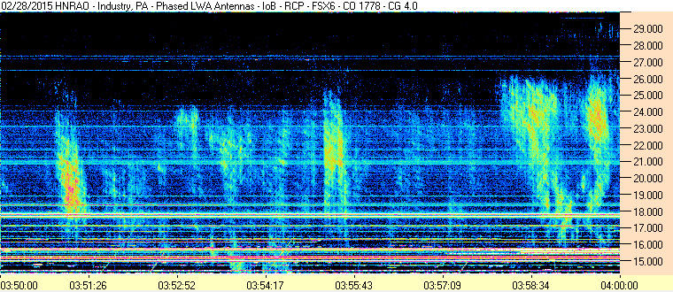

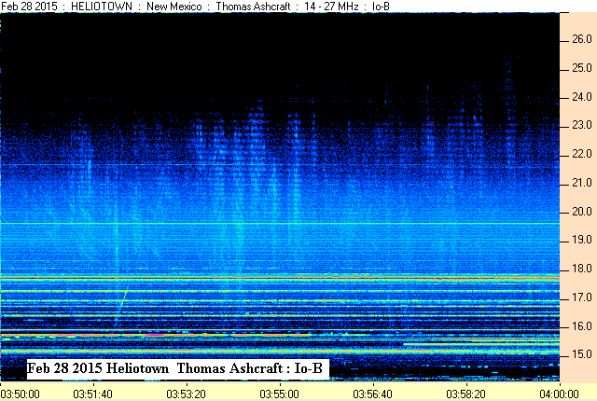

SUG Coordinated Observation 28 Feb 2015, 0350-0400 RCP & Linear

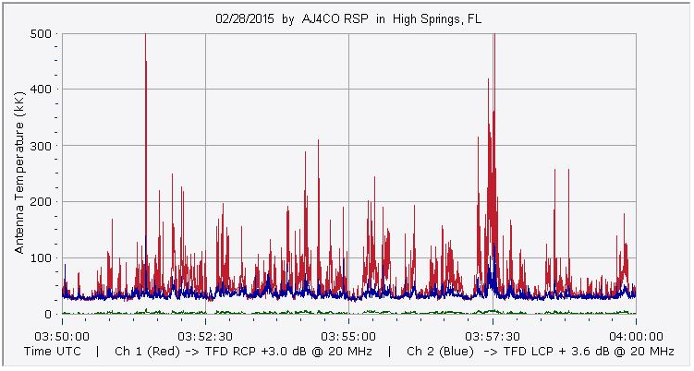

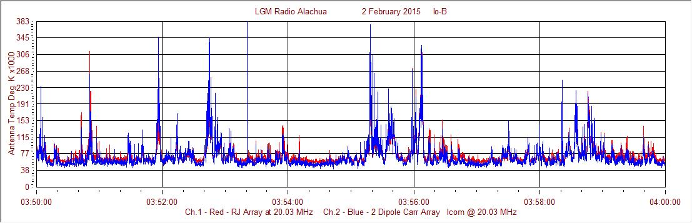

Francisco

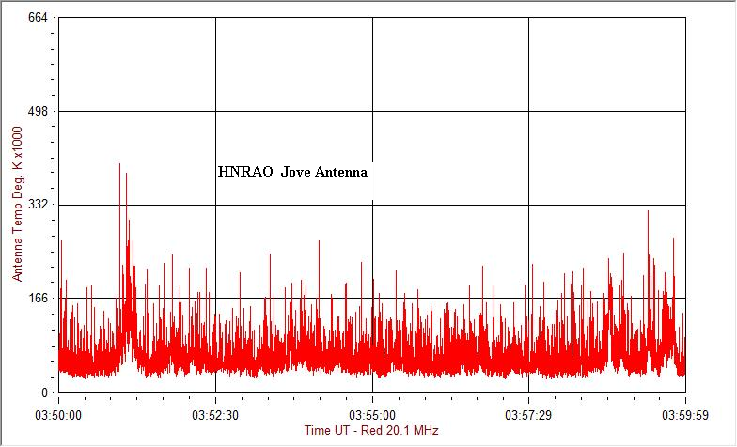

Compiled by RF, posted 15 March 2016

