SUG Coordinated Observation 28 Feb 2015, 0408-0411 RCP and Linear

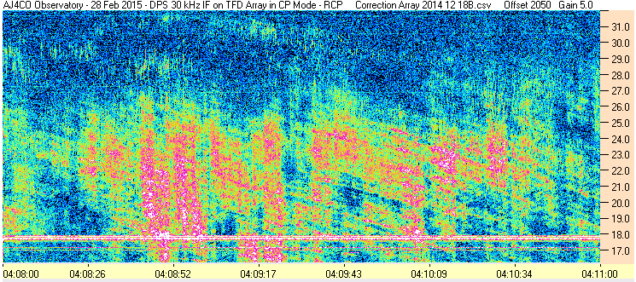

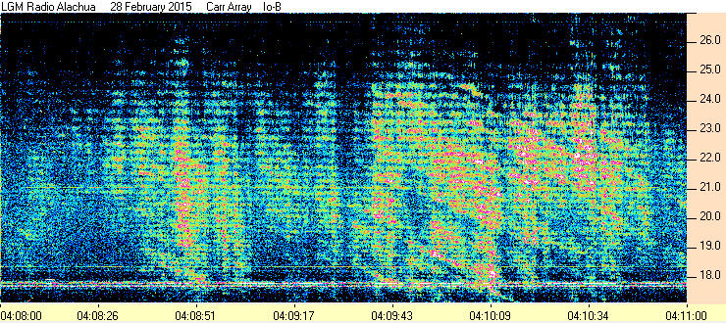

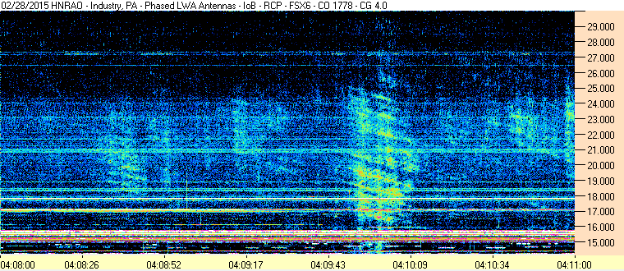

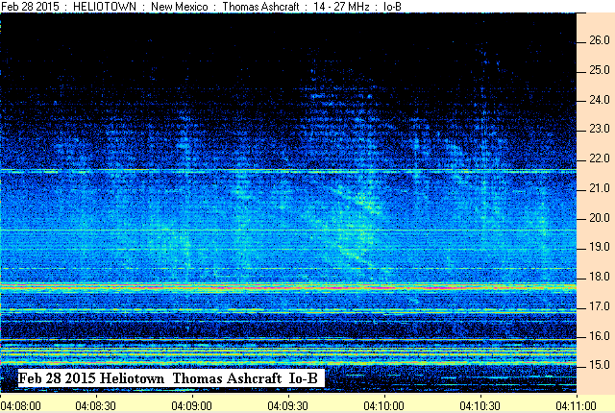

SUG Coordinated Observation 28 Feb 2015, 0408-0411 RCP & Linear

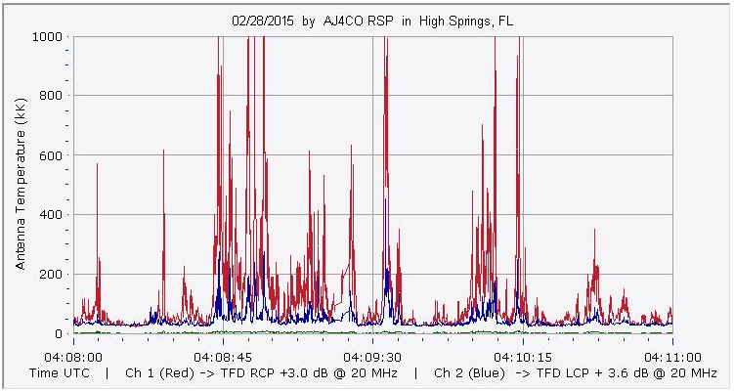

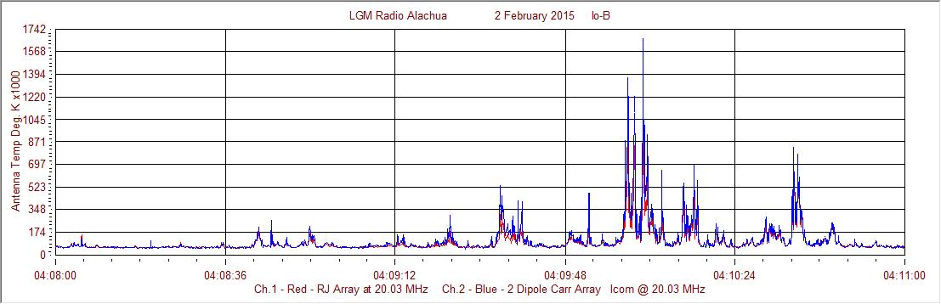

Francisco

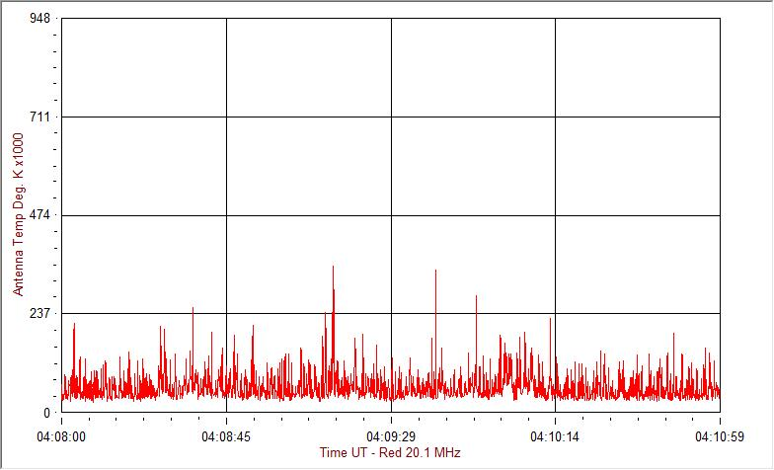
HNRAO

Compiled by RF, posted 15 March 2016

