SUG Coordinated Observation 28 Feb 2015, 0418-0422
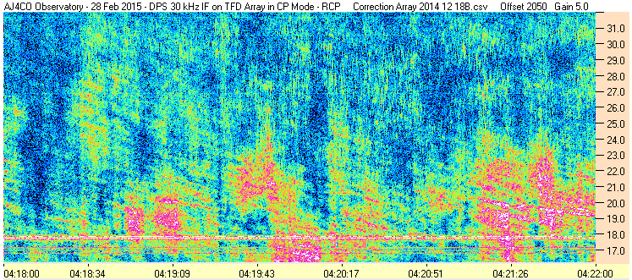

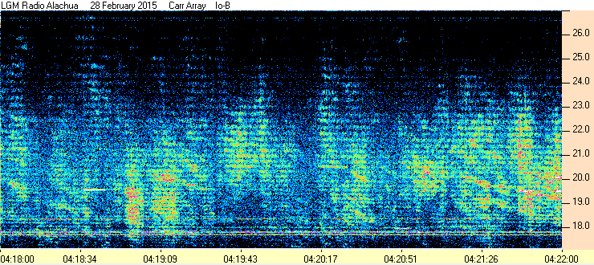

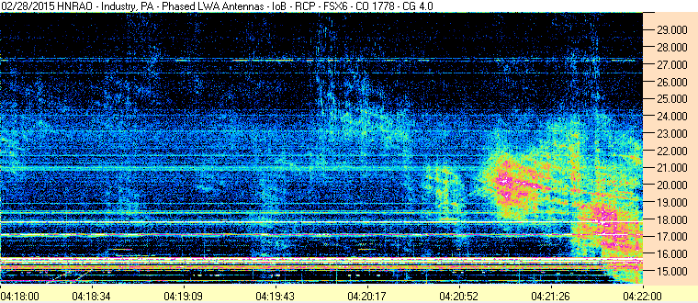

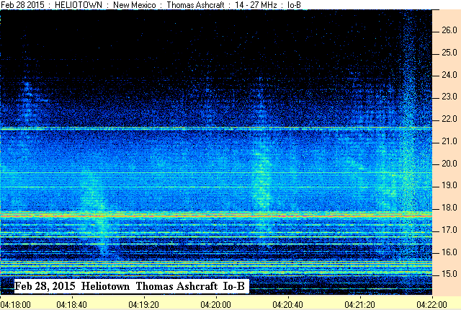

SUG Coordinated Observation 28 Feb 2015, 0418-0422 RCP & Linear

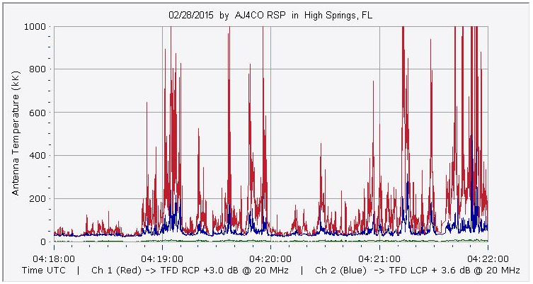

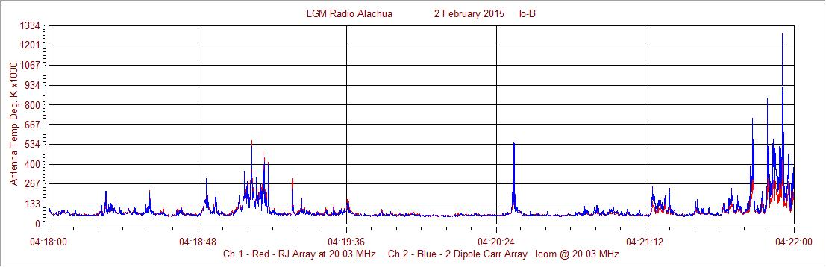

Francisco

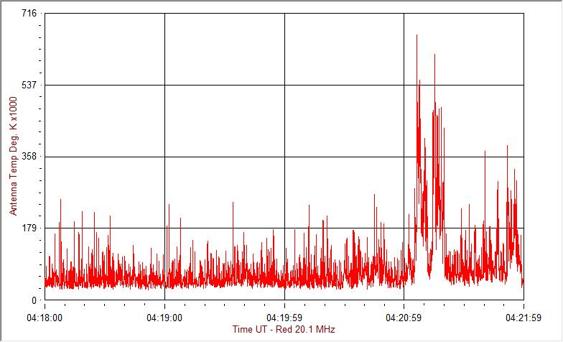
HNRAO

Compiled by RF, posted 15 March 2016

