Jan 7, 2014 Solar Burst as received at several SUG stations.

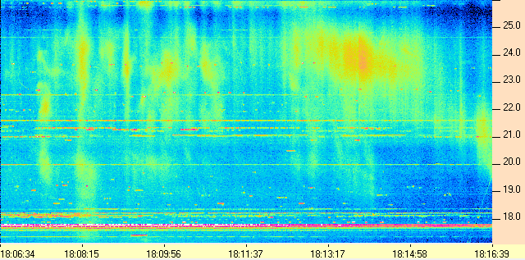
HNRAO

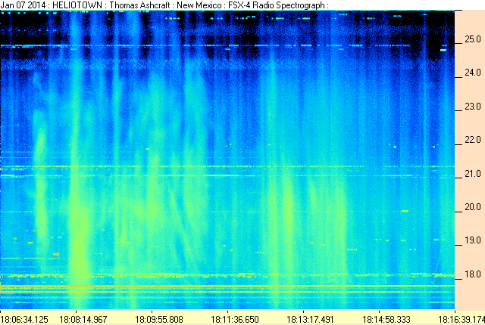
Heliotown

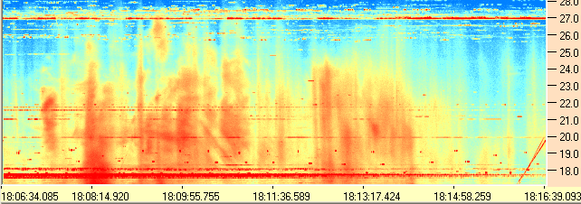
AJ4CO

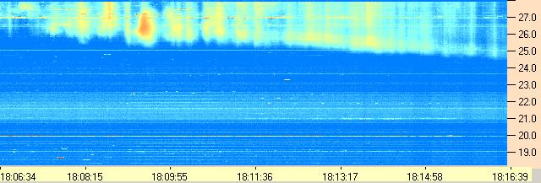 WCCRO

Compiled by RF, posted 15 March 2016

