Jan 27, 2014 SID as received at several SUG stations.

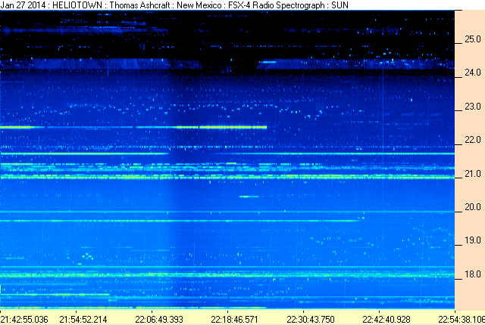

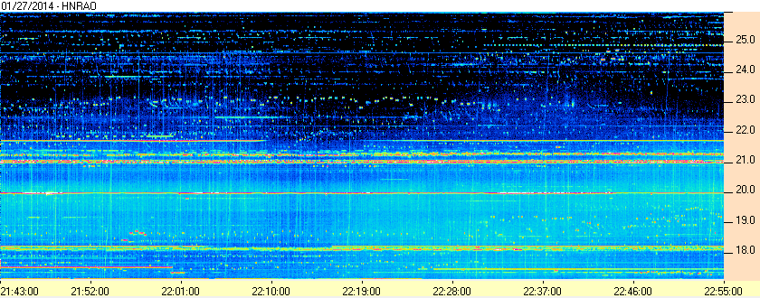

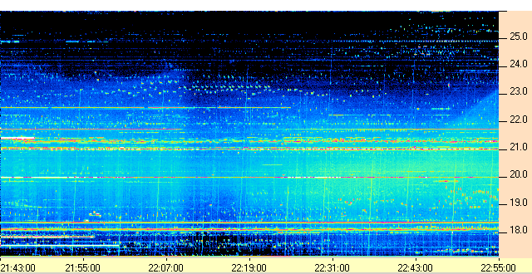
Radio Alachua

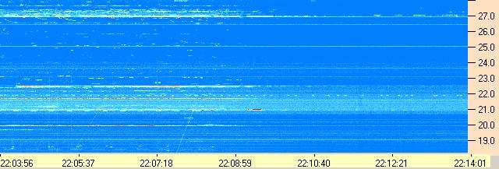
WCCRO (Note different time scale)

Compiled by RF, posted 15 March 2016

