Solar Burst 18 Jan 2016, 1741 UTC

Data Sources

 | Spectrograph | SkyPipe
Heliotown | 14-27 MHz, FSX-4  Jove dual dipole | 20.1 MHz, Jove rcvr,  dual dipole array
HNRAO | 17-28 MHz, FSX-2  4 element LWA, RCP | 20.1 MHz, Jove rcvr,  dual dipole array
Alachua | 15-30 MHz, FSX-1S  TFD array, dual pol | 20.1 MHz, two Jove rcvrs with freq offset, RCP/LCP  20.1 MHz Jove rcvr, Jove dual dipole array.
AJ4CO | 16-32 MHz DPS, Dual TFD squares, both corrected and uncorrected inages | 20.1 MHz, two Jove rcvrs with freq offset, RCP, LCP  20.1 MHz RCP/LCP polarization ratio plot
Notes
All antennas were phased for Jupiter observations – none were phased for solar observations. This makes comparisons of antenna temperatures difficult without taking the antenna patterns into account. This effect is particularly noticeable in the AJ4CO records since the dual TFD (terminated folded dipole) antenna beam is much sharper than the Jove dual dipole array beam.

The burst occurred very close to transit for east coast stations.
.
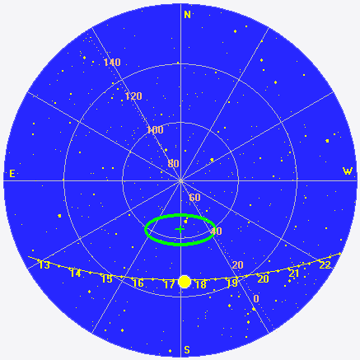
1. AJ4CO beaming pattern and sun location.
Spectrograms

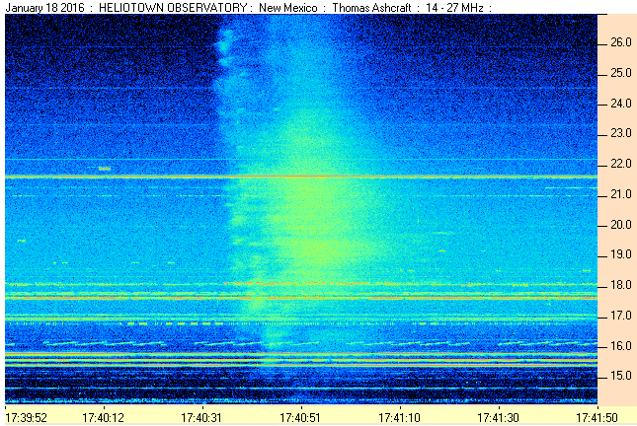
2. Heliotown 14-27 MHz, Jove array, linear polarization

3. HNRAO 17-28 MHz, LWA array RCP polarization

4. LGM Radio Alachua 15-30 MHz RCP on top panel, LCP bottom panel

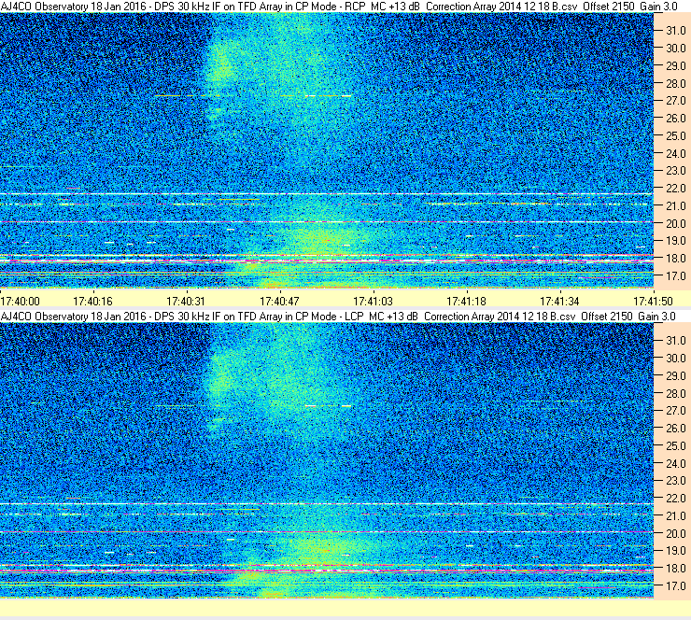
5. AJ4CO Using correction array. RCP top panel, LCP bottom panel
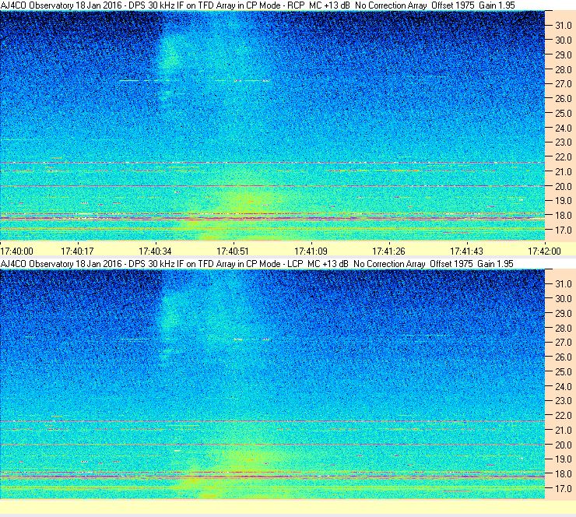
6. AJ4CO no correction array, RCP top panel, LCP bottom panel

SkyPipe

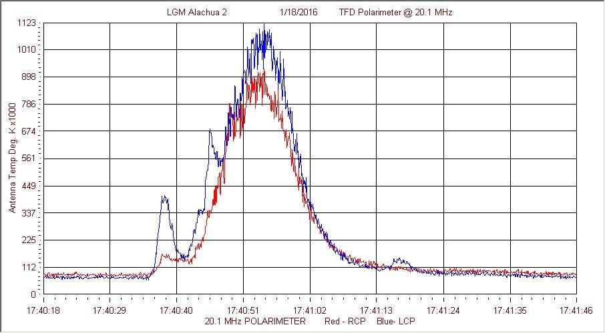
7. Radio Alachua, 20.1 MHz Polarimeter, Two Jove receivers with frequency offset.

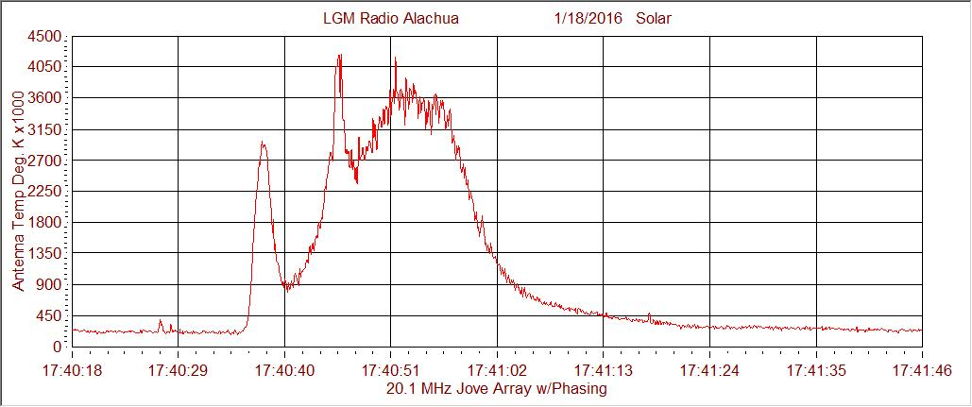
8. Radio Alachua, 20.1 MHz Jove dual dipole array, Jove receiver.

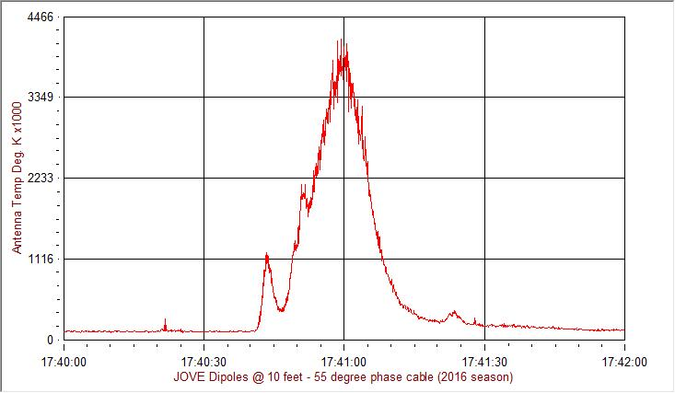
9. HNRAO, 20.1 MHz, Jove receiver and dual dipole array (phased to 55 deg south).

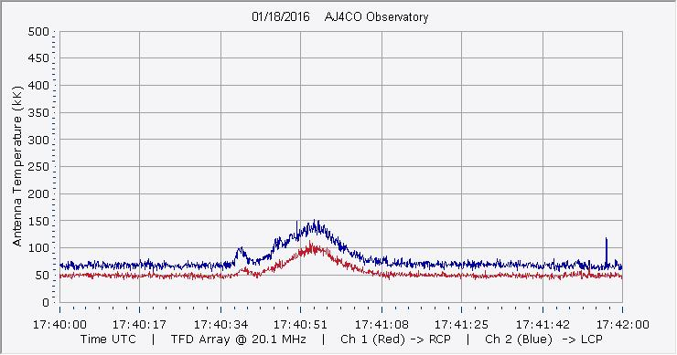
10. AJ4CO, 20.1 MHz dual Jove receivers on dual square TFD array phased for 30 deg South (sun was way down in the antenna beam response)

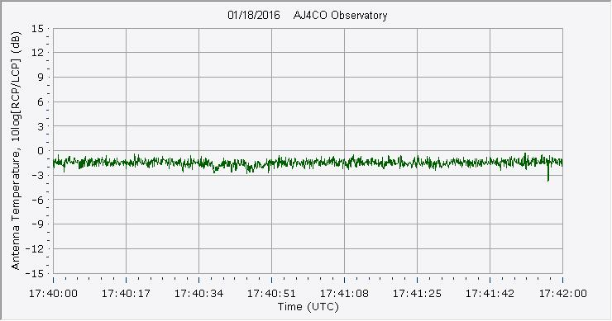
11. AJ4CO Ratio of antenna temperatures [10 LOG(RCP/LCP)]. Computed and displayed in SkyPipe using RCP and LCP temperatures from the two Jove receivers.

Compiled by RF, posted 15 March 2016

