SUG Observation Report — Date December 8, 2013

Observatory: | HNRAO | Instrumentation: | FSX Spectrograph
Location: | Industry, PA |  | JOVE II Receiver
Observer: | Jim Brown |  | Dual 20.1/24 MHz dipoles

Observer On Duty (UTC): | attended | Body: | Jupiter
Observer Off Duty (UTC): | attended | Storm Type: | Io-A

Storm Activity (UTC) |  | CML-III | Io φ | Off Axis | D_{E} | JS ∠ | Δ JE
Begin: | 0407 | 198.8 | 237.6
End: | 0601 | 263.2 | 252.6

Interval |  |  |  |  |  | F_{hi} | F_{lo} |  |  |  | Drift |  | Rot Rate | TEC
# | (UTC) | L | S | N | Pol | MHz | MHz | CML | Io | ML | MHz/m | FB | #/MHz @ F | 10¹⁶/m²
1
2
3
4
5
6

Interval – Time during which something interesting was observed  L, S, N – Indicates presence of L bursts, S bursts, and N events  Pol – Dominant circular polarization observed  Fhi, Flo – Frequency range of observed emission  CML, Io – System III CML and Io phase during noted interval | ML – indicates presence of modulation lanes  Drift – Observed modulation lane drift rate in MHz per minute  FB – indicates presence of Faraday bands  Rot Rate – Observed Faraday rotation rate in rotations per MHz at observing frequency F  TEC – Ionospheric vertical total electron count during noted interval as reported by NGDC

Observer Notes
L-Bursts with Faraday Lanes covering 17- to 24 MHz for the major portions of the storm. There were possibly modulation lanes. Activity was seen as high as 26 MHz between 0520 and 0540 UT and indications it went much higher. First indications of activity here at approximately 0407 UT. Began very weak with the strongest portion of the storm beginning at approximately 0513 UT and last activity was seen at 0601 UT.

Data File(s): | 131208041326_HNRAO.sps  131208051846_HNRAO.sps  131208052203_HNRAO.sps  131208052224_HNRAO.sps  131208052257_HNRAO.sps  131208052509_HNRAO.sps | 131208052905_HNRAO.sps  131208053339_HNRAO.sps  131208053448_HNRAO.sps  131208055500_HNRAO.sps

RJP Sky View

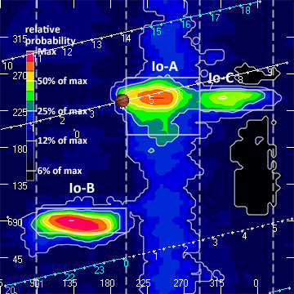

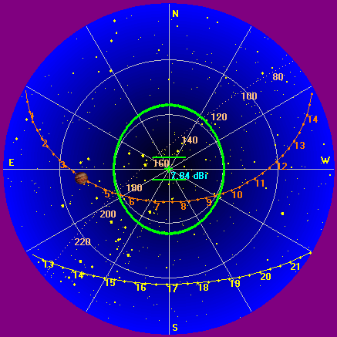

Instrumentation: | FSX  JOVE/24 MHz dual phased dipoles

Calibration Scale
Offset: 330
Gain: 2.5

Overview Spectrogram (675 sweeps)

