SUG Observation Report — Date Oct. 15, 2013

Observatory: | HNRAO | Instrumentation: | FSX Spectrograph
Location: | Industry, PA |  | JOVE II Receiver
Observer: | Jim Brown |  | Dual 20.1/24 MHz dipoles

Observer On Duty (UTC): | unattended | Body: | Jupiter
Observer Off Duty (UTC): | unattended | Storm Type: | Io-B

Storm Activity (UTC) |  | CML-III | Io φ | Off Axis | D_{E} | JS ∠ | Δ JE
Begin: | 0815 | 132.1 | 80.9
End: | 1000 | 195.2 | 95.7

Interval |  |  |  |  |  | F_{hi} | F_{lo} |  |  |  | Drift |  | Rot Rate | TEC
# | (UTC) | L | S | N | Pol | MHz | MHz | CML | Io | ML | MHz/m | FB | #/MHz @ F | 10¹⁶/m²
1 | 0815-1000 | X | X |  |  | 26 | 17.5 | 132.1 | 80.9 | X
2 | 0815-0816 |  | X |  |  | 21 | 17 | 132 | 80.9
3 | 0816-0817 |  | X |  |  | 23.5 | 17 | 132.6 | 81
4 | 0817-0819 |  | X |  |  | 24 | 17 | 133.5 | 81.3
5 | 0819-0820 |  | X |  |  | 22.5 | 21 | 134.4 | 81.5
6 | 0822-0823 |  | X |  |  | 25 | 19 | 136.2 | 81.9
7 | 0826-0828 |  | X |  |  | 23.5 | 20.5 | 138.9 | 82.5 |  | 2.5/1
8 | 0834-0836 |  | X |  |  | 23 | 17 | 143.8 | 83.7 |  | 6/2
9 | 0850-0900 | X |  |  |  | 25 | 17.5 | 152.8 | 85.8 | X | 2/3
10 | 0855-0910 | X |  |  |  | 26 | 17.5 | 160.1 | 87.5 | X | 2/3

Interval – Time during which something interesting was observed  L, S, N – Indicates presence of L bursts, S bursts, and N events  Pol – Dominant circular polarization observed  Fhi, Flo – Frequency range of observed emission  CML, Io – System III CML and Io phase during noted interval | ML – indicates presence of modulation lanes  Drift – Observed modulation lane drift rate in MHz per minute  FB – indicates presence of Faraday bands  Rot Rate – Observed Faraday rotation rate in rotations per MHz at observing frequency F  TEC – Ionospheric vertical total electron count during noted interval as reported by NGDC

Observer Notes
Not particularly strong in L-Bursts but some periods of strong S-Burst activity. The storm started about 0815 UT and continued through approximately 1000 UT. The most intense L-Burst activity seems to have occurred between 0850 UT and 0900 UT. Strongest S-Burst activity was 0835:30 UT. Storm frequency spanned from about 17 MHz to 26 MHz. Faraday Lanes visible and appear near horizontal. Some modulation lanes were also visible. The event started with S-Bursts and could be seen throughout the storm with L-Bursts also present. Sweep range 17-26 MHz with 300 channels.

Data File(s): | HNRAO131015081500.sps  HNRAO131015085000.sps  HNRAO131015085500.sps  HNRAO_S_131015081500.sps  HNRAO_S_131015083404.sps | HNRAO_S_131015081756.sps  HNRAO_S_131015081924.sps  HNRAO_S_131015082220.sps  HNRAO_S_131015082644.sps

Io-CML Phase Plane

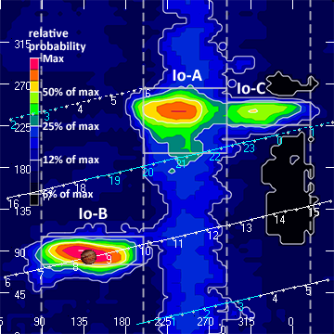

RJP Sky View

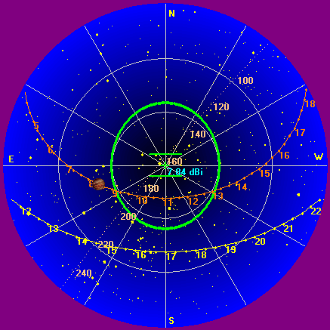

Instrumentation: | FSX Spectrograph - Sweep range 17-26 MHz – 300 channels.  JOVE/24 MHz dual phased dipoles

Calibration Scale

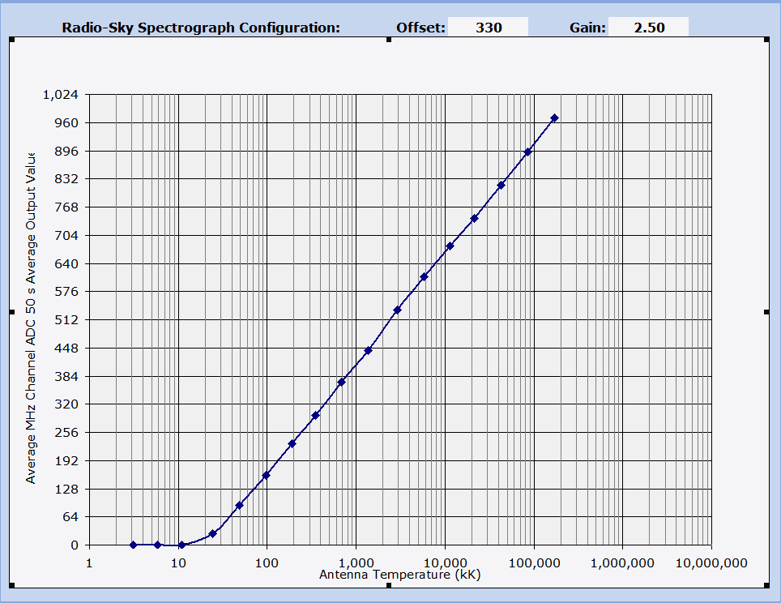

Overview Spectrogram

