SUG Observation Report — Date November 30, 2013

Observatory: | HNRAO | Instrumentation: | FSX Spectrograph
Location: | Industry, PA |  | JOVE II Receiver
Observer: | Jim Brown |  | Dual 20.1/24 MHz dipoles

Observer On Duty (UTC): | attended | Body: | Jupiter
Observer Off Duty (UTC): | attended | Storm Type: | Io-B/Non-Io-B

Storm Activity (UTC) |  | CML-III | Io φ | Off Axis | D_{E} | JS ∠ | Δ JE
Begin: | 0601 | 150 | 65.9
End: | 0659

Interval |  |  |  |  |  | F_{hi} | F_{lo} |  |  |  | Drift |  | Rot Rate | TEC
# | (UTC) | L | S | N | Pol | MHz | MHz | CML | Io | ML | MHz/m | FB | #/MHz @ F | 10¹⁶/m²
1
2
3
4
5
6

Interval – Time during which something interesting was observed  L, S, N – Indicates presence of L bursts, S bursts, and N events  Pol – Dominant circular polarization observed  Fhi, Flo – Frequency range of observed emission  CML, Io – System III CML and Io phase during noted interval | ML – indicates presence of modulation lanes  Drift – Observed modulation lane drift rate in MHz per minute  FB – indicates presence of Faraday bands  Rot Rate – Observed Faraday rotation rate in rotations per MHz at observing frequency F  TEC – Ionospheric vertical total electron count during noted interval as reported by NGDC

Observer Notes
Composed almost entirely of S-Bursts, this event was also populated with S-N burst events. There were periods of strong S burst activity. Activity was between 19 and 23 MHz, and seemed to be centered on 21 MHz. The storm started near 19 MHz and quickly jumped to near 23 MHz and began dropping in frequency ending slightly below 21 MHz. There was brief activity at 20.1 MHz (Radio JOVE) between 0629 UT and 0636 UT.

Data File(s):

RJP Sky View

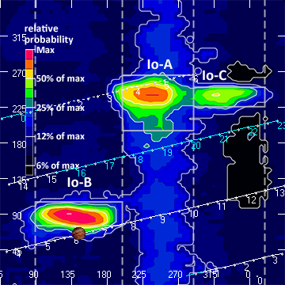

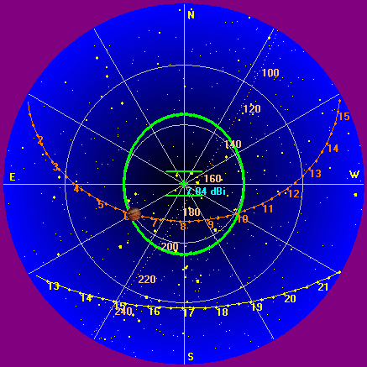

Instrumentation: | FSX  JOVE/24 MHz dual phased dipoles

Calibration Scale
Offset: 330
Gain: 2.5

Overview Spectrogram (675 sweeps)

