SUG Observation Report — December 16, 2013

Observatory: | HNRAO | Instrumentation: | FSX Spectrograph
Location: | Industry, PA |  | JOVE II Receiver
Observer: | Jim Brown |  | Dual 20.1 MHz dipoles

Observer On Duty (UTC): | unattended | Body: | Jupiter
Observer Off Duty (UTC): | unattended | Storm Type: | Io-B

Storm Activity (UTC) |  | CML-III | Io φ | Off Axis | D_{E} | JS ∠ | Δ JE
Begin: | 0735 | 86.1 | 94.2
End: | 0941 | 162.3 | 112.1

Interval |  |  |  |  |  | F_{hi} | F_{lo} |  |  |  | Drift |  | Rot Rate | TEC
# | (UTC) | L | S | N | Pol | MHz | MHz | CML | Io | ML | MHz/m | FB | #/MHz @ F | 10¹⁶/m²
1
2
3
4
5
6

Interval – Time during which something interesting was observed  L, S, N – Indicates presence of L bursts, S bursts, and N events  Pol – Dominant circular polarization observed  Fhi, Flo – Frequency range of observed emission  CML, Io – System III CML and Io phase during noted interval | ML – indicates presence of modulation lanes  Drift – Observed modulation lane drift rate in MHz per minute  FB – indicates presence of Faraday bands  Rot Rate – Observed Faraday rotation rate in rotations per MHz at observing frequency F  TEC – Ionospheric vertical total electron count during noted interval as reported by NGDC

Observer Notes
Weak L-bursting even though Jupiter was well within the beam of the antennas. Only significant L-bursting seen with SkyPipe at 20.1 MHz was at 0816 UT. On images below, FSX set with Offset: 330 and Gain: 1.5.

Data File(s): | 131216073000HNRAO.sps  131216083000HNRAO.sps  131216093000HNRAO.sps | 131216080000HNRAO.sps  131216091500HNRAO.sps

RJP Sky View

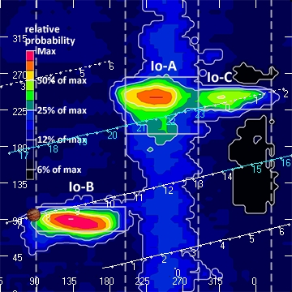

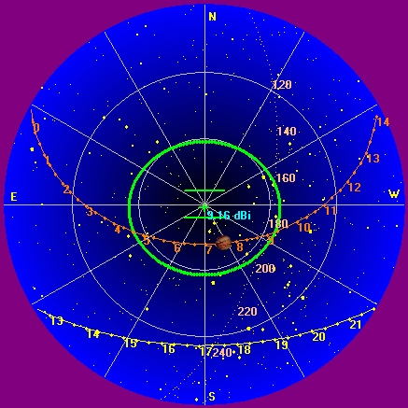

Instrumentation: | FSX  20.1 MHz dual phased dipoles

Calibration Scale

Offset: 330
Gain: 1.5

Overview Spectrogram (675 sweeps)

