SUG Observation Report — Date 10/11/2013

Observatory: | HNRAO | Instrumentation: | FSX Spectrograph
Location: | Industry, PA |  | JOVE II Receiver
Observer: | Jim Brown |  | Dual 20.1/24 MHz dipoles

Observer On Duty (UTC): | Unattended | Body:
Observer Off Duty (UTC): | Unattended | Storm Type: | Non-Io-B

Storm Activity (UTC) |  | CML-III | Io φ | Off Axis | D_{E} | JS ∠ | Δ JE
Begin: | 0934 | 297.3 | 358.7
End: | 0951 | 307.6 | 1.1

Interval |  |  |  |  |  | F_{hi} | F_{lo} |  |  |  | Drift |  | Rot Rate | TEC
# | (UTC) | L | S | N | Pol | MHz | MHz | CML | Io | ML | MHz/m | FB | #/MHz @ F | 10¹⁶/m²
1 | 0934 | X |  |  |  | 21 | 18
2
3
4
5
6

Interval – Time during which something interesting was observed  L, S, N – Indicates presence of L bursts, S bursts, and N events  Pol – Dominant circular polarization observed  Fhi, Flo – Frequency range of observed emission  CML, Io – System III CML and Io phase during noted interval | ML – indicates presence of modulation lanes  Drift – Observed modulation lane drift rate in MHz per minute  FB – indicates presence of Faraday bands  Rot Rate – Observed Faraday rotation rate in rotations per MHz at observing frequency F  TEC – Ionospheric vertical total electron count during noted interval as reported by NGDC

Observer Notes
Non-Io-B appears to have started about 0934 UT and ended about 0951 UT. Seems to have started around 21 MHz and drifted down to just below 18 MHz. L-Bursts with Faraday lanes visible. Probability was at 12%.

Data File(s): | HNRAO_131011093000.sps  HNRAO_131011094400.sps

RJP Sky View
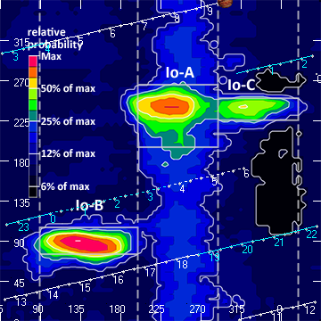

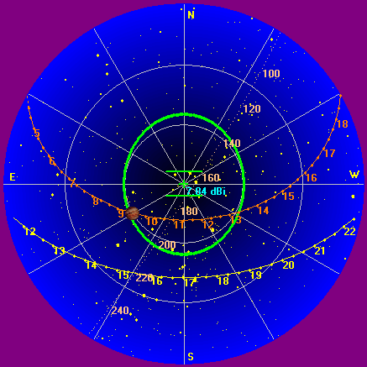

Instrumentation: | FSX  JOVE/24 MHz dual phased dipoles

Calibration Scale

Offset: | 333 | Gain: | 2.40

Overview Spectrogram (675 sweeps)

