Items in BLUE should be completed by observer if possible

Items in YELLOW would be nice too, but are not necessary

Items in WHITE are not necessary; will be completed by group report author

SUG Observation Report — 05 Oct 2013

Observatory: | HNRAO | Instrumentation:
Location: | Industry, PA |  | FS-JOVE – 24 MHz Array
Observer: | Jim Brown |  | Jove Receiver on JOVE Array

Observer On Duty (UTC): | unattended | Body: | Jupiter
Observer Off Duty (UTC): | unattended | Storm Type: | Io-A

Storm Activity (UTC) |  | CML-III | Io φ | Off Axis | D_{E} | JS ∠ | Δ JE
Begin: | 1130 | 184.3° | 235° | ° | +1.8° | –78° | 5.3 AU
End: | 1400 | 275° | 256.3° | ° | +1.8° | –78° | 5.3 AU

Interval |  |  |  |  |  | F_{hi} | F_{lo} |  |  |  | Drift |  | Rot Rate | TEC
# | (UTC) | L | S | N | Pol | MHz | MHz | CML | Io | ML | MHz/m | FB | #/MHz @ F | 10¹⁶/m²
1 | 1130-1400 | X |  |  |  | 23 | 19
2
3
4
5
6

Interval – Time during which something interesting was observed  L, S, N – Indicates presence of L bursts, S bursts, and N events  Pol – Dominant circular polarization observed  Fhi, Flo – Frequency range of observed emission  CML, Io – System III CML and Io phase during noted interval | ML – indicates presence of modulation lanes  Drift – Observed modulation lane drift rate in MHz per minute  FB – indicates presence of Faraday bands  Rot Rate – Observed Faraday rotation rate in rotations per MHz at observing frequency F  TEC – Ionospheric vertical total electron count during noted interval as reported by NGDC

Observer Notes

Data File(s): | HNRAO-131005112200.sps  HNRAO-131005114000.sps

RJP Sky View

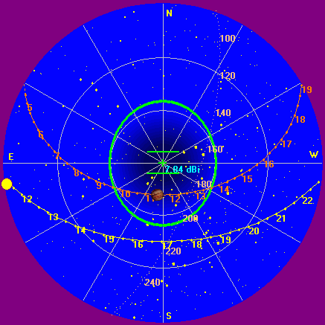

Instrumentation: | FSX on JOVE / 24 MHz Dipoles

Calibration Scale

Overview Spectrogram

