SUG Observation Report — Date

Observatory: | HNRAO | Instrumentation: | FSX Spectrograph
Location: | Industry, PA |  | JOVE II Receiver
Observer: | Jim Brown |  | Dual 20.1/24 MHz dipoles

Observer On Duty (UTC): | Unattended | Body:
Observer Off Duty (UTC): | Unattended | Storm Type: | Non-Io-B

Storm Activity (UTC) |  | CML-III | Io φ | Off Axis | D_{E} | JS ∠ | Δ JE
Begin: | 0936 | 148.2 | 155.5
End: | 1011 | 169.3 | 160.4

Interval |  |  |  |  |  | F_{hi} | F_{lo} |  |  |  | Drift |  | Rot Rate | TEC
# | (UTC) | L | S | N | Pol | MHz | MHz | CML | Io | ML | MHz/m | FB | #/MHz @ F | 10¹⁶/m²
1 |  | x
2
3
4
5
6

Interval – Time during which something interesting was observed  L, S, N – Indicates presence of L bursts, S bursts, and N events  Pol – Dominant circular polarization observed  Fhi, Flo – Frequency range of observed emission  CML, Io – System III CML and Io phase during noted interval | ML – indicates presence of modulation lanes  Drift – Observed modulation lane drift rate in MHz per minute  FB – indicates presence of Faraday bands  Rot Rate – Observed Faraday rotation rate in rotations per MHz at observing frequency F  TEC – Ionospheric vertical total electron count during noted interval as reported by NGDC

Observer Notes

Data File(s): | HNRAO131010093500.sps  HNRAO131010093600.sps  HNRAO131010095100.sps | HNRAOUT131010094002.spd  HNRAOUT131010095713.spd

RJP Sky View
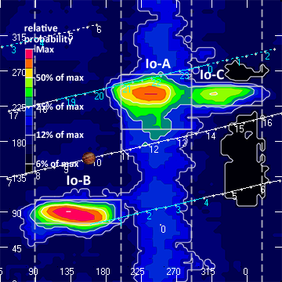

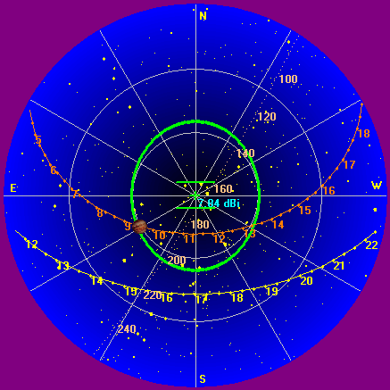

Instrumentation: | FSX  JOVE/24 MHz dual phased dipoles

Calibration Scale

Offset: | 333 | Gain: | 4.70

Overview Spectrogram (675 sweeps)

